(WriteDown)

In-class translation app

Project Team: OJBK

Ruifeng Zhu

Mengmeng Liu

Yangling Hu

Yiheng Jiang

Ruifeng zhu: work for the Android interface

Yangling Hu: work for the database

mengmeng Liu: work for the AI handwrting reconginiton

Yiheng Jiang:work for the api stuff.

Table of Contents

**1. Project Definition (**100 - 200 words**)** – *Group responsibility*

* This application generally works for international students to take notes in class. According to the report, millions of international students come to America for study, for most of those students are suffering from the understanding of the classes, because of the unknown words. At this point, “write down” is the application can help them get to know the course clearly. The goal for “write down” is to use the original way like the notebook to allow students to take notes on the electronic devices, and in the meantime, it will recognize the handwriting by users and translate to their languages which can help students learn their course better. And also, these notes which users were created can be saved as their own account, the users can easily view edit, delete and download their notes all the time. Also, The purpose of shard board is to allow users allow to their notes online for a better learning. This application will be available for the Android operating system first.

**2.Project Requirements** – *Group responsibility*

**Functional** ：

•1.Recognize the users handwritings get the value to use for the next step.

•2.Use the words form step 1 and translate to the language which users want.

•3. Save the notes to the account (cloud).

•4.SignIn/Signup to allow users for more functions.

•5.History board allow users to delete, download the notes.

•6.Share Board allow users to share their notes with each others(Learning area).

**Usability:**

-UI: the UI interface will have a login and register function.It will have a username ,password bar and a register icon.

-Database interface: the interface system for user account will need to be included a method to save information such as the words translated,and get another method to get the saved information

-Hardware interfaces :the application must take input from any generic touch screen in order for the user to navigate the menus and output to any current generic monitor compatible with Android cellphone.

**Performance**:

Write down project will allow at least 500 user login at the same time.

Writedown project will save client information after each transaction closure to prevent information loss because the crash or loss.

**System:**

Developer language:java,SQLite

it will be a mobile application

Write Down project will require a Android operating system on a mobile phone with the minimum requirement specifications to run said operating system. For the database, the system works on SQLite.

**Security:**

SHA256.

**3. Project Specification** – *Group responsibility*

* Focus / Domain / Area

For our application, we want to focus on the students who study abroad. Basic for the Asian students (Especially for Chinese international student).

* Libraries / Frameworks /Development Environment

Glide/ MVC /android studio.

* Platform (Mobile, Desktop, Gaming, Etc).

Basically for any Android devices both smartphones and tablets. (Apple software would be added later on.)

* Genre (Game, Application, etc).

It is a Multi-function note application. (reference, tool, efficiency).

-------------------------------------------------work on for the below-----------------------------------------

**4. System – Design Perspective** – *Group responsibility*

* Identify subsystems – design point of view
  + Illustrate with class, use-case, UML, sequence ..... diagrams
  + 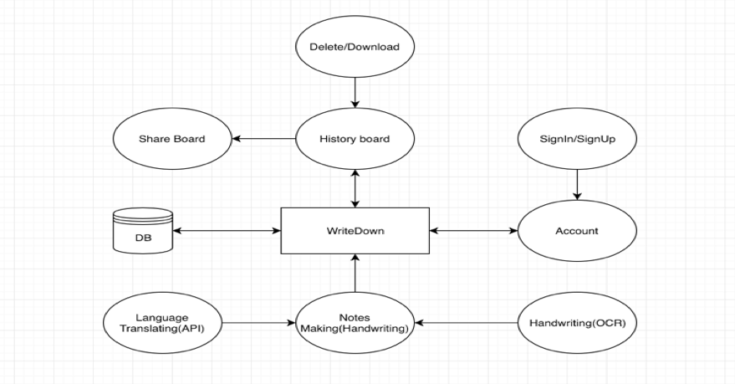
  + Design choices (Optional)
* Sub-System Communication (Diagram and Description)
  + Controls
  + I/O
  + DataFlow
* Entity Relationship Model (E-R Model)
  + Example - <https://en.wikipedia.org/wiki/Entity%E2%80%93relationship_model>
* Overall operation - System Model
* Simplified Sub-system to System interaction

**5. System – Analysis Perspective** – *Group responsibility*

* Identify subsystems – analysis point of view
* System (Tables and Description)
  + Data analysis
    - Data dictionary (Table - Name, Data Type, Description)
  + Process models
* Algorithm Analysis
  + Big - O analysis of overall System and Sub-Systems

**6. Project Scrum Report -** *Group Responsibility*

* Product Backlog (Table / Diagram)
* Sprint Backlog (Table / Diagram)
* Burndown Chart

**7. Subsystems**

**7.1 Subsystem 1** – Name 1 - *Individual responsibility*

* Initial design and model
  + Illustrate with class, use-case, UML, sequence ..... diagrams
  + Design choices
* Data dictionary
* If refined (changed over the course of project)
  + Reason for refinement (Pro versus Con)
  + Changes from initial model
  + Refined model analysis
  + Refined design (Diagram and Description)
* Scrum Backlog (Product and Sprint - Link to Section 6)
* Coding
  + Approach (Functional, OOP)
  + Language
* User training
  + Training / User manual (needed for final report)
* Testing

**7.2 Subsystem 2** – Name 2 - *Individual responsibility*

* Initial design and model
  + Illustrate with class, use-case, UML, sequence ..... diagrams
  + Design choices
* Data dictionary
* If refined (changed over the course of project)
  + Reason for refinement (Pro versus Con)
  + Changes from initial model
  + Refined model analysis
  + Refined design (Diagram and Description)
* Scrum Backlog (Product and Sprint - Link to Section 6)
* Coding
  + Approach (Functional, OOP)
  + Language
* User training
  + Training / User manual (needed for final report)
* Testing

**7.3 Subsystem 3** – Name 3 - *Individual responsibility*

* Initial design and model
  + Illustrate with class, use-case, UML, sequence ..... diagrams
  + Design choices
* Data dictionary
* If refined (changed over the course of project)
  + Reason for refinement (Pro versus Con)
  + Changes from initial model
  + Refined model analysis
  + Refined design (Diagram and Description)
* Scrum Backlog (Product and Sprint - Link to Section 6)
* Coding
  + Approach (Functional, OOP)
  + Language
* User training
  + Training / User manual (needed for final report)
* Testing

**7.4 Subsystem 4** – Name 4 - *Individual responsibility*

* Initial design and model
  + Illustrate with class, use-case, UML, sequence ..... diagrams
  + Design choices
* Data dictionary
* If refined (changed over the course of project)
  + Reason for refinement (Pro versus Con)
  + Changes from initial model
  + Refined model analysis
  + Refined design (Diagram and Description)
* Scrum Backlog (Product and Sprint - Link to Section 6)
* Coding
  + Approach (Functional, OOP)
  + Language
* User training
  + Training / User manual (needed for final report)
* Testing

**8. Complete System** – *Group responsibility*

* Final software/hardware product
* Source code and user manual – screenshots as needed - Technical report
  + Github Link :<https://github.com/lxmshisg/WriteDown>
* Evaluation by client and instructor
* Team Member Descriptions